Documentation

Development of employment levels (geringfügige Beschäftigung):



🡪 many, but not all, Bundesländer have seen an increase in the employment level for low wage work since the wave of refugees

Development of the number of refugees relative to the population in each Bundesland:



Difference in Refugees relative to the Population between 2014 and 2016:

Ein Bild, das Tisch enthält.

🡪 two Bundesländer which would be good for comparison are Mecklenburg-Vorpommern and Schleswig-Holstein as they are very comparable since they are located next to each other and have a comparable size. Also they are on opposite ends regarding the change in refugees per population

🡪 another idea would be to compare Mecklenburg-Vorpommern and Bremen since they took in the least and most refugees relative to their population, respectively. However, one is a city and one is not densely populated so they may not be directly comparable.

Development of refugees relative to the population in Germany and Switzerland:



🡪 we can see that Germany took many more refugees in than Switzerland

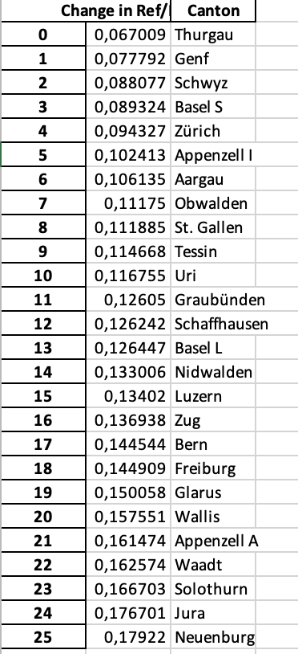

* Genf & Waadt oder Solothurn & Aargau

Results National Data

In order to validate the necessary common trend assumption, we looked at the development over time of the unemployment rate, the total employment level and the employment level of foreigners in Germany and Switzerland.

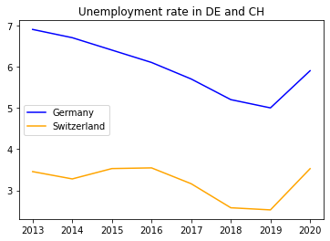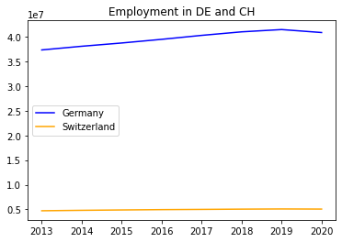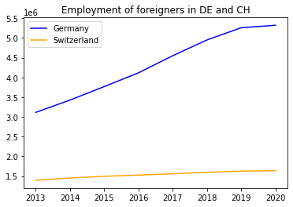

As one can see, the trends pre-2015 are similar but not all the same. However, we can make the assumption that Switzerland and Germany are comparable since they have similar demographics, institutions etc.

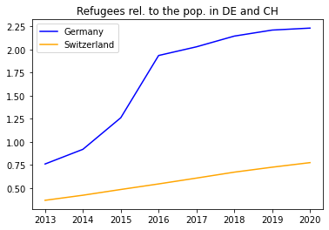

When we look at the number of refugees relative to population size, we can see a development as expected. The numbers in Germany increase exponentially from mid-2014 while they only increase linearly in Switzerland. After 2016 this exponential trend levels off.

Next, let us look at the results of the ATET estimation.